MORNING WORSHIP SERVICE
Dec 6, 2015

Opening Song “This Is the Day” 359

Opening Prayer/Announcements
K s b c

Keeping His Word through Sunday School, Bible Study and Church Attendance/Worship

Sunday School Bible Studies for December:

Dec. 6th Adopted into God’s Family 1 John 3:1-10 Dec. 13th Freed by God’s Forgiveness John 8:2-11 Dec. 20th Saved by God’s Son John 1:1-5,9-14 Dec. 27th Strengthened by God’s power Ephesians 3:14-21

9:45 a.m. each Sunday – A place for everyone

WE’D LOVE FOR YOU TO JOIN US!

Worship Hymns “joy to the World! The Lord Is come” 87
“Away in a Manger” 103
“Hark! The Herald Angels Sing” 88
“How Great Is our God”
“How Great Thou Art” 10

Offering/Offertory

Special Music Sharon Harbison

Message Bro. David Atwood

Invitation

This week, we will begin collecting food items for Christmas meal boxes. We are helping 6 local families in need. The boxes will be filled Dec 20 @ 4:30 if anyone would like to participate in this wonderful ministry.

Closing Prayer

Evening Service 6:00

Living Proof Live
March 4-5, 2016 (Fri & Sat)
Waco, TX: Extraco Event Center
Contact Patti Radford if you might be interested in attending

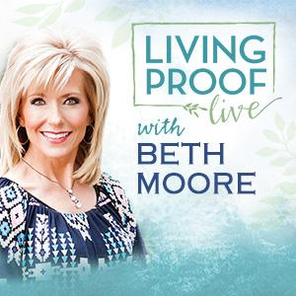
NURSERY – available for children age 0 to Kindergarten
Cissy Atwood

Hostesses for December Ushers for December
Dianne Lindemann, Shelia Waggoner, Kenny Merrell, Jimmy Miller,
Michael & Peggy Hammonds Wayne Marecle, Joe Daniel

Immediate Need Prayer List
Prayer & Request Information

(Please complete name & address information on reverse side)

❑ I would like to speak with the Pastor.

❑ I would like more information on this church.

❑ I have Prayer Requests or Needs

Date:

Permission to Publicize:
Church Bulletin  Yes  No
Email Prayer Chain  Yes  No

Prayer Request:

Prayer For
Name
Address
Phone

Given By
Name
Address
Phone
Please Contact By

❑ Card  Phone  Visit

Comments

Pray for Pat Dismukes Murdoch – cancer

Pray for Justin Wilson as he recovers from injuries sustained in a car accident

